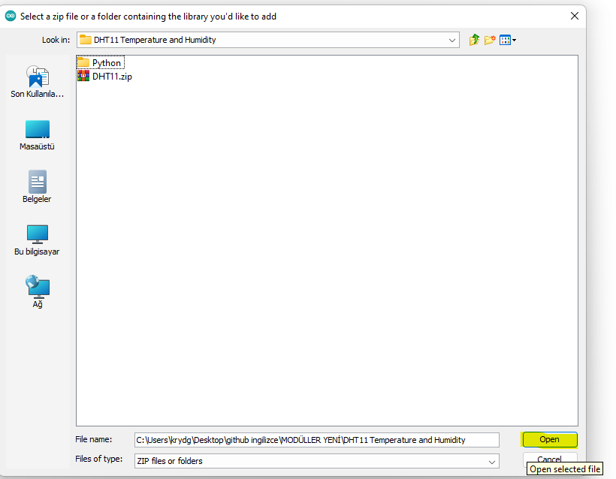
Select the sketch tab from the Arduino IDE application, then click the Add .ZIP library option from the add library tab.

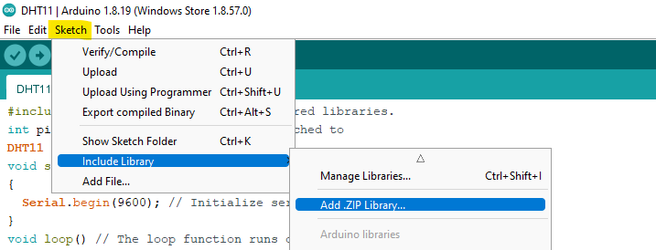

Find the folder we downloaded from the opened window and open the .zip file.

